**Osaki Midori 尾崎 翠 (1896–1971)**

SUMMARY

Osaki Midori was a writer of short stories, poetry, essays, dramatic works, and a novel. Characterized as a Modern Girl, she is often discussed alongside writers such as Hasegawa Shigure, Kaneko Misuzu, and Nomizo Naoko. Her works feature female experiences in the city, sisterhoods and female relationships, and discussions of sensorial and aesthetic boundaries. Although she only published across two decades, her works were rediscovered toward the end of her life, and scholarship on them has continued in the decades following her passing.

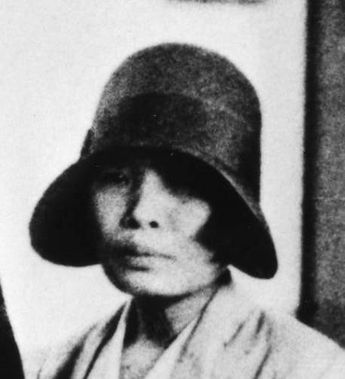

Osaki Midori

<http://www.library.pref.tottori.jp/kyodo/osaki_midori.html>

MAIN ENTRY

Osaki Midori was born on 20 December 1896 (Meiji 29) in Tottori Prefecture. Her father, Osaki Chōtarō, was a primary school principal; her mother was from a family heading a Buddhist temple. As a secondary school student, Osaki read and submitted works to magazines such as *Bukyō sekai* (supervised by Oshikawa Shunrō), *Joshi bundan*, and *Bunshō sekai*. In 1912 she began publishing her poetry in the magazine *Takane*.

She became a *daiyō kyōin* (an instructor without a teaching credential who taught at primary schools in Japan before World War II) after graduating in 1912, but with a publication inthe literary magazine *Shinchō* in 1916 and stories for girls published in *Shōjo sekai* in 1917, Osaki decided to focus on writing, relocating to Tokyo and entering Japan Women’s University in 1919. There she befriended Matsushita Fumiko, who became an important part of Osaki’s life.

With the help of poet Ikuta Shungetsu, also from Tottori, Osaki released “Mufūtai kara” (“From the Doldrums”) in the January 1920 issue of *Shinchō*. The publication, however, was reproached by the university, and Osaki was forced to leave the university. She focused on writing while living in Tokyo with Matsushita, who left the university along with Osaki.

Osaki published many works for girls, and imagery of physical ailments is frequent in them, stemming from her experiences of caring for Matsushita and Osaki’s own older brother when they were ill. For example, Osaki’s story “Shōjo Lala yo—Denki monogatari” (“Young Girl Lala—A Romance”) (1927) features a girl named Lala who is blind. The story is an adaptation of Mori Ōgai’s Japanese translation of Hans Christian Andersen’s *Improvisatoren* (*The Improvisatore*), and we see in her works the influence of *Omokage*, a journal that published Japanese translations of Western poetry, edited by writers such as Ōgai and Ochiai Naobumi. In 1928 Hayashi Fumiko, who was serializing *Hōrōki* in Hasegawa Shigure’s literary magazine *Nyonin geijutsu*, introduced Osaki to Hasegawa. Osaki also came to publish works in *Nyonin geijutsu*, including the drama *Appuru pai no gogo* (*Apple Pie Afternoon*) (1929), for which she gained critical recognition, and the film criticism series *Eiga mansō* (*Film Thoughts Overflow*) (1930).

Osaki’s crowning achievement was *Dainana kankai hōkō* (*Wandering the Seventh Realm*) (1931), which was serialized in *Shinkō geijutsu kenkyū* at the request of Itagaki Takao, a scholar of art and modernism. *Wandering* explored the idea of a seventh sense—beyond the five senses, beyond even a sixth sense—which Osaki described as the aesthetic sense of writer and poet. That same year Osaki published the short story “Hokō” (“Walking”), in which the narrator walks throughout her neighborhood like a flâneur in order to forget about a psychologist whom she met while he was conducting research in her hometown. The story, moving forward in spurts of flashbacks, is a meta-narrative on the relationship among walking, writing, and forgetting. This was followed by the publication of “Koorogi-jō” (“Miss Cricket”) and “Chikashitsu Anton no ichiya” (“Basement Anton’s Night”) in 1932. The former deals with layers of illusions surrounding a female character who takes a certain medication with side effects; the latter consists of thoughts of a poet who suffers from a lost love. These works—*Wandering* and on—share the same characters who build layers of fantasies and narrations across texts.

Around this time Osaki began to experience physical and mental ailments, including hallucinations. In 1932, while living with Takahashi Takeo, a lover 10 years her junior, Osaki experienced a series of emotional problems stemming from drug addiction, leading to her return to Tottori. Osaki never returned to Tokyo and ceased publishing in 1941. Even after *Wandering* received renewed attention in 1969, she refused interviews with the press. She passed away from pneumonia on 8 July 1971 (Shōwa 46) at the age of 74 and was laid to rest at Yōgen Temple in Tottori City, which was run by her mother’s family. There has been a resurgence in scholarship about Osaki and her works, which also became the subjects of two films—*Osaki Midori wo sagashite* (*Searching for Osaki Midori*) (1999) and *Koorogi-jō* (*Miss Cricket*) (2006), both directed by Hamano Sachi.

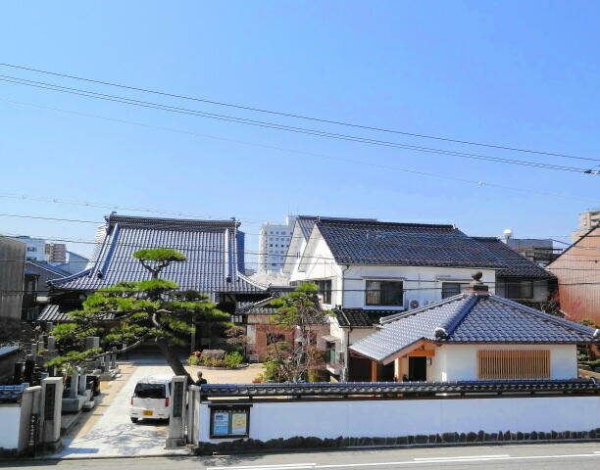

Yōgen Temple in Tottori City, where Osaki was laid to rest.

<http://www.ncn-t.net/yogenji/> © Keiunzan Yōgenji

**List of Works**

Collected works

*Osaki Midori zenshū* (1979), Tokyo: Sohjusha.

*Teibon Osaki Midori zenshū* (2 vols, 1998), Tokyo: Chikuma shobō.

Poetry

*Chōhen aishi: Go-ji no fue* [*Elegy: The Five o’clock Whistle*] (1920)

Short stories

“Mufūtai kara” [“From the Doldrums”] (1920)

“Hokō” [“Walking”] (1931)

“Koorogi-jō” [“Miss Cricket”] (1932)

“Chikashitsu Anton no ichiya” [“Basement Anton’s Night”] (1932)

Drama

*Appuru pai no gogo* [*Apple Pie Afternoon*] (1929)

Essays

*Eiga mansō* [*Film Thoughts Overflow*] (1930)

Novel

*Dainana kankai hōkō* [*Wandering the Seventh Realm*] (1931)

Screenplay

*Ruri-dama no mimiwa* [*Lapis Lazuli Earrings*] (unreleased)

English translation

Osaki Midori. (2008) “Shoes Fit for a Poet”, tr. William Jefferson Tyler, in *Modanizumu: Modernist Fiction from Japan, 1913–1938*, ed. William Jefferson Tyler, Honolulu: University of Hawai‘i Press, 83–91.

**References and further reading**

Aoyama, Tomoko. (2009) “Genealogy of the ‘Girl’ Critic Reading Girl”, in *Girl Reading Girl in Japan*, eds. Tomoko Aoyama and Barbara Hartley, New York: Routledge, 38–49.

Kawasaki Kenko. (2008) “Osaki Midori and the Role of the Girl in Shōwa Modernism”, tr. Lucy Fraser and Tomoko Aoyama, *Asian Studies Review* 32 (3): 293–306.

Yonogi, Reiko. (2012) “Modernism and Gender in Osaki Midori’s Works”, *Japan Studies Association Journal* 10: 110–120.

Satoko Kakihara, California State University, Fullerton